**Power BI Assignment**

**Covid19 Live Report:**

**Data source:** Fetch the form the live data sources, modify the query in such a way so that the data will refresh automatically on a daily basis.

Source: <https://raw.githubusercontent.com/CSSEGISandData/COVID-19/master/csse_covid_19_data/csse_covid_19_daily_reports/07-19-2020.csv>

**Data modelling:** Check whether the source data is in the correct format, if required then apply some transformation.

**Report KPI’s:** Create a report page with multiple visualization. Include the following KPI’s in the report page.

* **Total Confirm Cases-** Use Rotating tile to display the Total Confirm Cases, also append an icon at the end of the measure.
* **Total Deaths-** Use Rotating tile to display the Total Deaths, also append an icon at the end of the measure.
* **Total Recovered-** Use Rotating tile to display the Total Recovered, also append an icon at the end of the measure.
* **Total Country/Region affected-** Use Rotating tile to display the Country/Region affected, also append an icon at the end of the measure.
* **Total Active Cases-** Use Rotating tile to display the Total active cases, also append an icon at the end of the measure.
* **Country wise total cases-** Use Stroller visual to display country-wise total number of cases.
* **Country wise total confirm cases, total death, total recovered, incident rate (per 100k), fatality ratio-** Use a Map visual to display location-wise total number of cases and the other measures.
* **Country wise total cases in descending order by total cases-** Include a table visual to display the total number of cases in descending order.
* **Logo-** Display company logo.
* **Header-** Include the top header which will show the report detail.
* **Last Refreshed date-time-** To display data last refresh date time.
* **Home button-** Include the home button, use this button to navigate to the Landing page.
* **Landing Page-** Display a covid19 image, also include a link to navigate to the report page.
* **Landing Page Info Icon-** Include information icon, when the user clicks on it, it will display the information about the report.

**Report Design:** The following configuration need to include in the report-

Landing Page1:



Landing Page2:

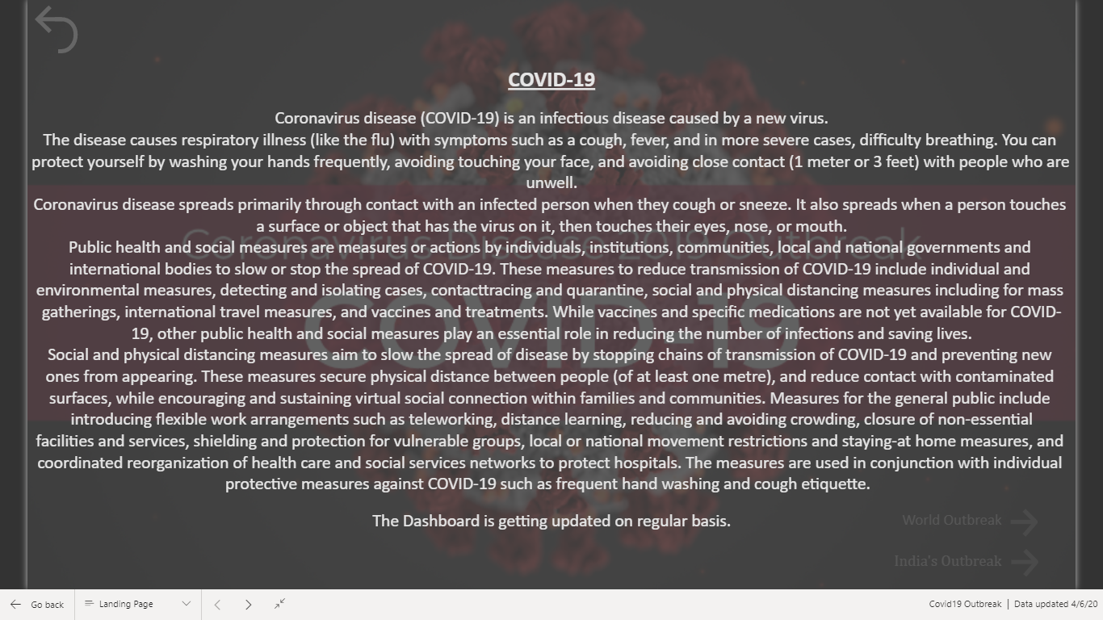

Report Page1:

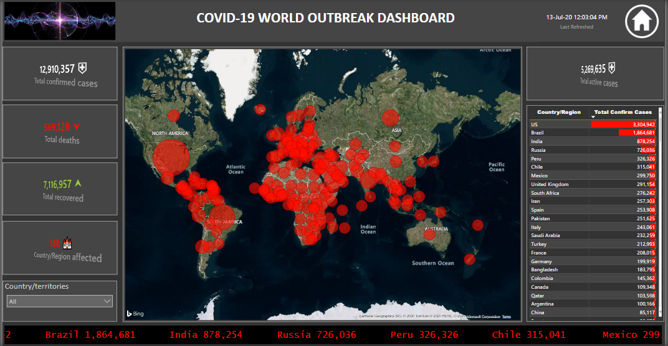

Report Page2:

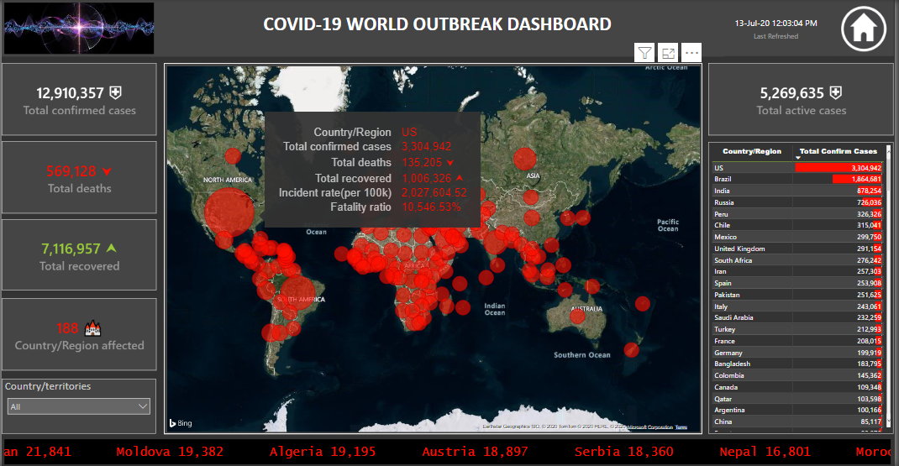

**Cloud Integration:** After creating the report, publish it to the Power BI services, so that it can be available from anywhere at any time.

**Scheduled Refresh:** Configure auto-refresh on a daily basis into the Power BI services.

Note: As you are not able to publish the report please upload your pbix file .Do not mention your name in the file (only group number )